When signing up after entering user name and password, the third box is for language. Change to English.

How to make first app ∠
Make First App!
1. On homepage choose button "File" in toolbox, then button "New"
2. Type File name, e.g. test123
3. Choose game from the games list, each game icon presents layout on the screen
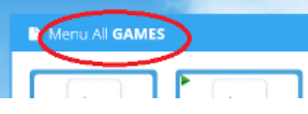
4. In this step, selected game needs to be filled with pictures. Select category of pictures, in this example we
have selected "Animals".
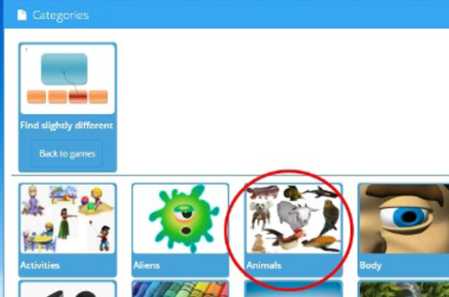
Select object within picture category. In this example Cheetah is selected.
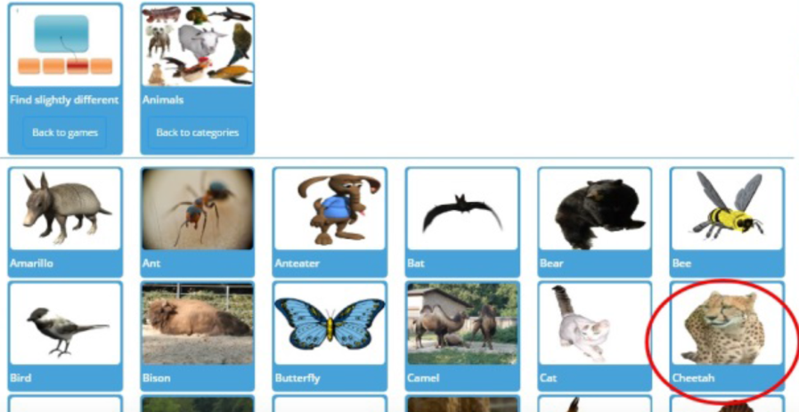
Finally, in this step, select picture or more pictures within selected object. Only selected pictures will appear in
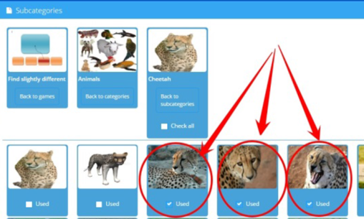
created App. Select at least 3 or more for this game

Save.
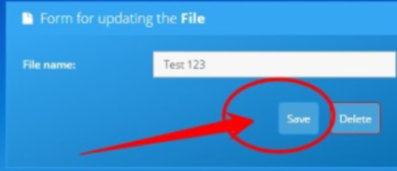

Run your first App on homepage, just click on App.
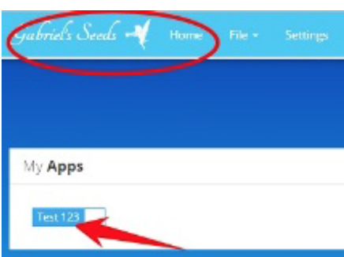
Add Background Sound!
Open new file or add music to old file with "Edit". File > Edit > Backgroud music
And save

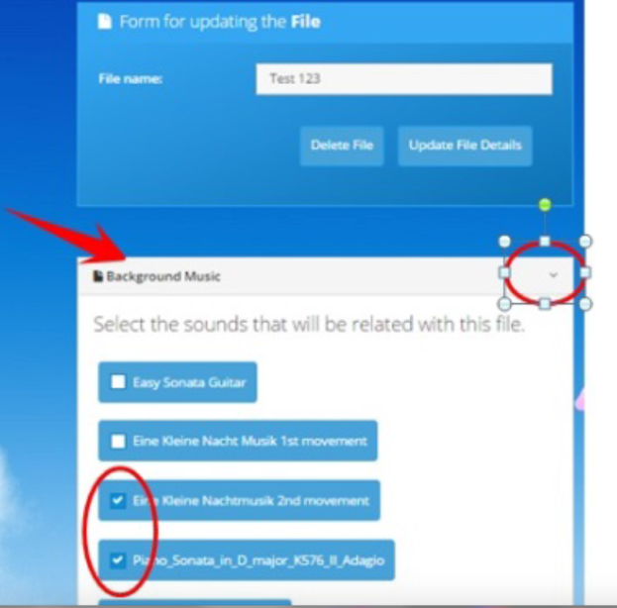
Add Motivators Within App!

Learning App can be so much more interesting if it uses "motivators". We are using educative videos or games
as motivation and attention boost after correct answers.
Open new file or add rewards to old file with "Edit". File > Edit > File rewards
Select rewards
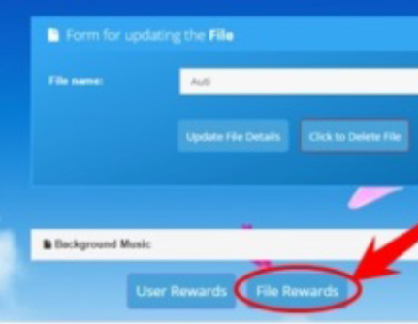
Rewards are organized in more pages, list through all rewards. Don't forget to save rewards selection by clicking close rewards panel
Important Note: Some games do not play rewards.
Finally, Reward duration can be be modified. Select "File Settings" (File > Edit > File Settings) and type reward
duration in seconds at "Reward time:" cell. For complete video duration check "Comp'lete duration" checkbox
below "Reward time" bar.
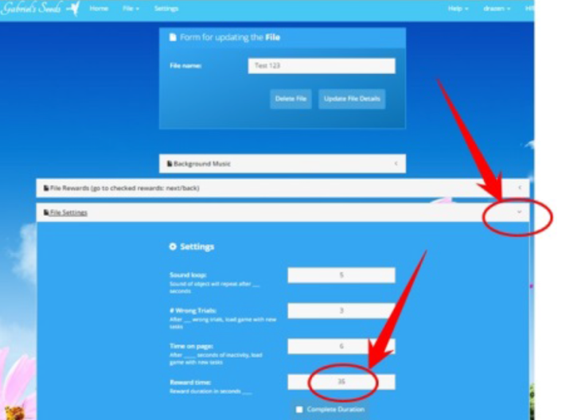

Add Motivators Within User Account!
Motivators can be set per user account. Select rewards in "User rewards" (File > Edit > User rewards)
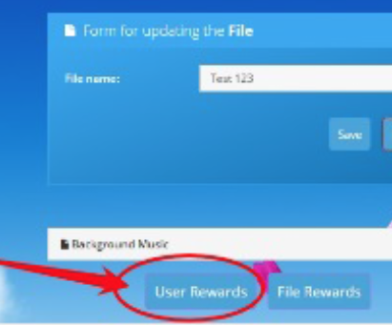
Save your work.

Define rewards source in Settings. Set rewards type at "User based rewards". All Apps will have random play of selected rewards from user profile.
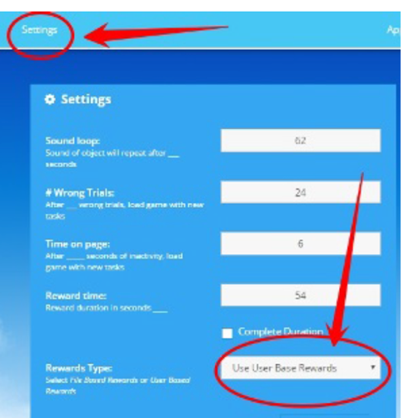

Share Your Apps!
Select files for sharing with checkmarks, right side of the cell with description. Press "Share" button.
Copy link, CTRL + C, Enter. Press OK
Your work is ready to share, paste link wherever you want and distribute it.
The shared player must create an account with Gabriel Seeds to access the game.

